**LAB 08: CALENDER USING GOOD DESIGN PRINCIPLE**

SCREEN 01 SCREEN 02

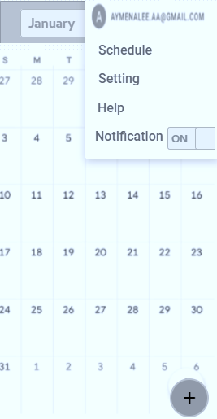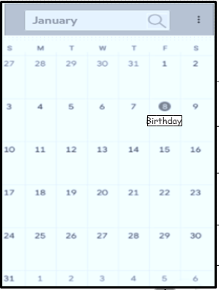

SCREEN 03 SCREEN 04

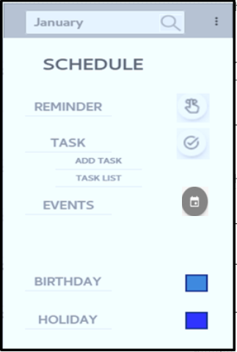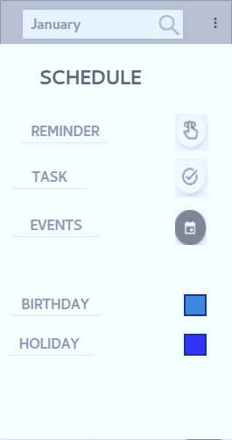

SCREEN 05 SCREEN 06

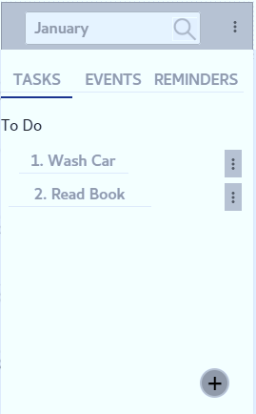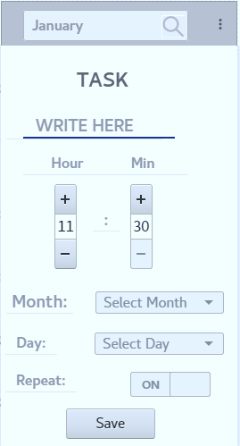

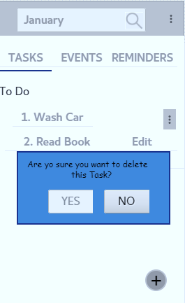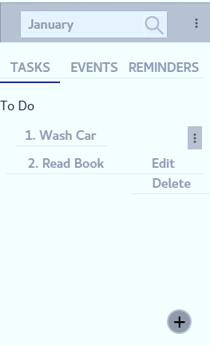 SCREEN 07 SCREEN 08

* Reflecting on how you went about tackling this activity?

Tackling this activity emphasizes our way that we have to see many factors that comes from user or customer side that we need to tackle down and then break these problems into small problems. We need to see as many as possible situation where we need to enhance our design to make such type of design that will relate user conceptual design in which user feel to use it easily otherwise impression will be negative. It’s broader our way of thinking to find out bes possible solution.

* What did you do first?

Firstly we need to understand the requirements then have to decide functionalities and have to make mock sheets (handily drawn design) then we made its actual prototype by keeping in mind all design principles.

* Did you have any particular artifacts or experience to base your design upon?

It’s particularly related with real life calendar in which we mark birthdays, events, tasks etc. Google calendar is a also particular related with our this design.

* What process did you go through?

In this we have to see many different aspects like good screen design principle in order to make it easier to use, the color we use are cover up all types of blindness red, blue, yellow, monochrome blindness etc. We use here feedback system, guidance and menu for navigation the best possible way we made it user friendly and also we thought to make it in a best possible way that our conceptual design actually relatable to our users or customers design that they made in their minds.